Linear Regression Lecture Notes

Model Evaluation: Cross-Validation & Bootstrapping

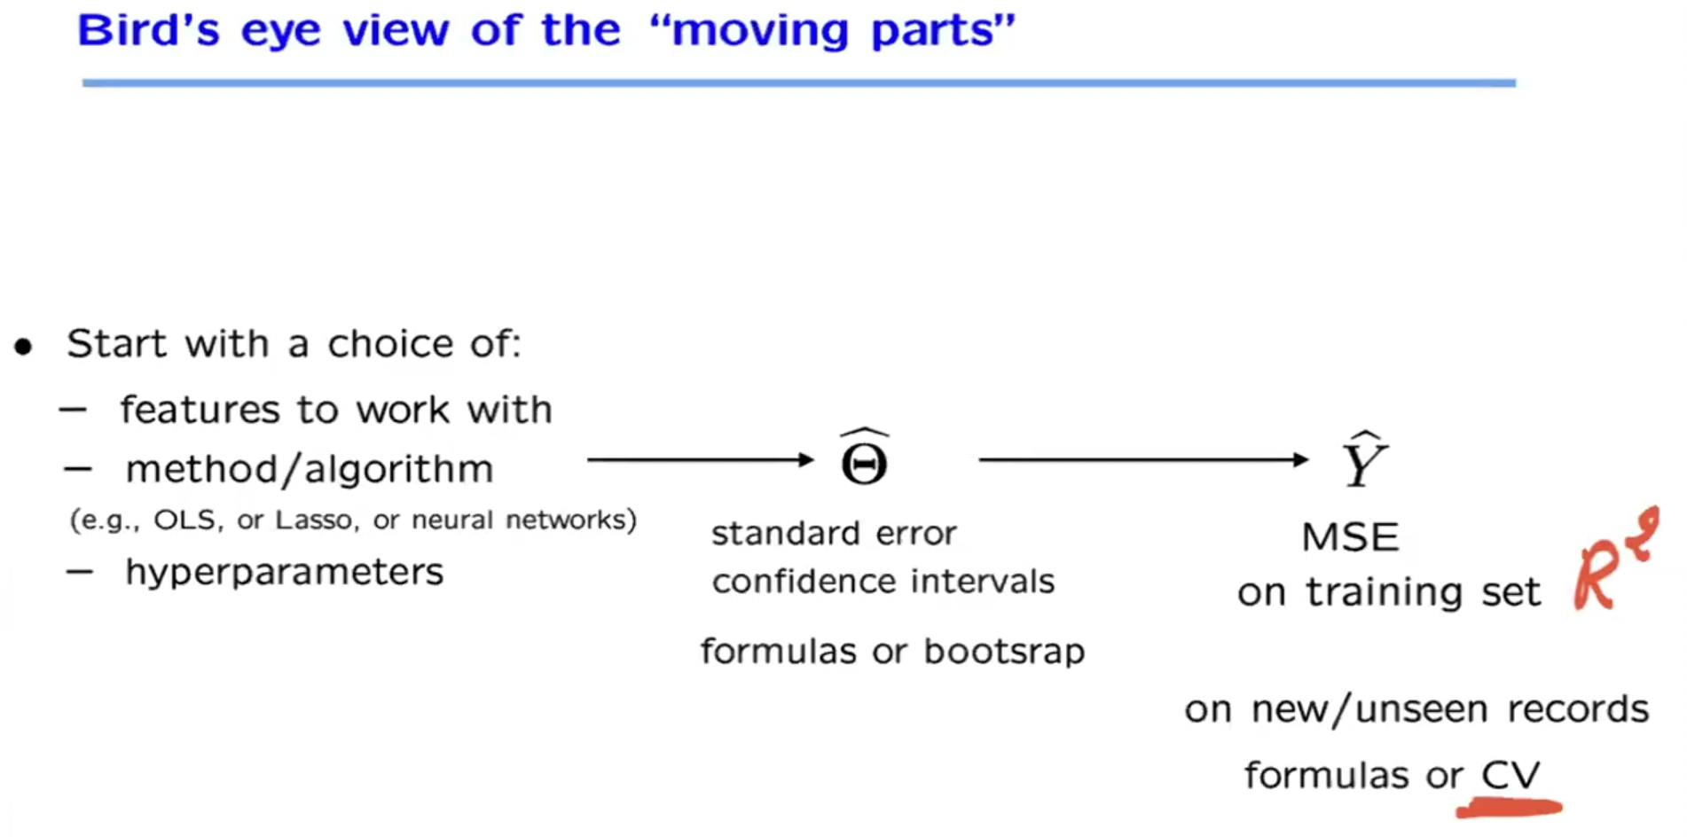

Bootstrapping is technique where random sample which is representative of true population which is unknown.

Shubham Sharma: So this is a smart technique which is helping us to just create more and more samples out of the existing sample that we have so that we can calculate different estimates of our parameters, and then accordingly build a sampling distribution of in that that way. We can have more confidence in the estimates that we create.

Shubham Sharma: Yeah, we can. Yeah, sure. So when we are doing bootstrap, let's say, we create 100 different samples. So what we'll do is we'll get 100 different estimates of our Theta hat, so we can definitely calculate average and use that as a reference. But we can. There is more use of bootstrap

**Key takeaways**

* ﻿﻿Linear regression is powerful and versatile
* ﻿﻿Foundation for more advanced prediction methods
* ﻿﻿Use with caution
* ﻿﻿be careful about interpretations
* ﻿﻿validate!

Prof. John Tsitsiklis: The words of caution that these apply not just. We illustrate them on linear regression, but they are generally valid. Be careful about interpretations. A good fit doesn't mean that vou have discovered a causal relation.

For example

Prof. John Tsitsiklis: there might be hidden variables that are important and hidden. Variables do damage linear regression. They also damage any other type of statistical method, and you should always validate the results at the end. Look at performance on data that you have not seen before, to see if you are generalizing well enough.

02:08:02 / 02:39:31

**Recordings**

All recordings from the course - Machine Learning

Introduction to Supervised Learning: Regression

17 Jun 25·12:00 AM to 2:00 AM

[Introduction to Supervised Learning: Regression](https://olympus.mygreatlearning.com/recordings/2737232?th=gm&pb_id=18129)

Model Evaluation: Cross-Validation & Bootstrapping

18 Jun 25·12:00 AM to 2:00 AM

[Model Evaluation: Cross-Validation & Bootstrapping](https://olympus.mygreatlearning.com/recordings/2737320?th=gm&pb_id=18129)